**Case Study**

**1. Write a program which will find factors of given number and find whether the factor is even or odd. Hint: Use Loop with if-else statements**

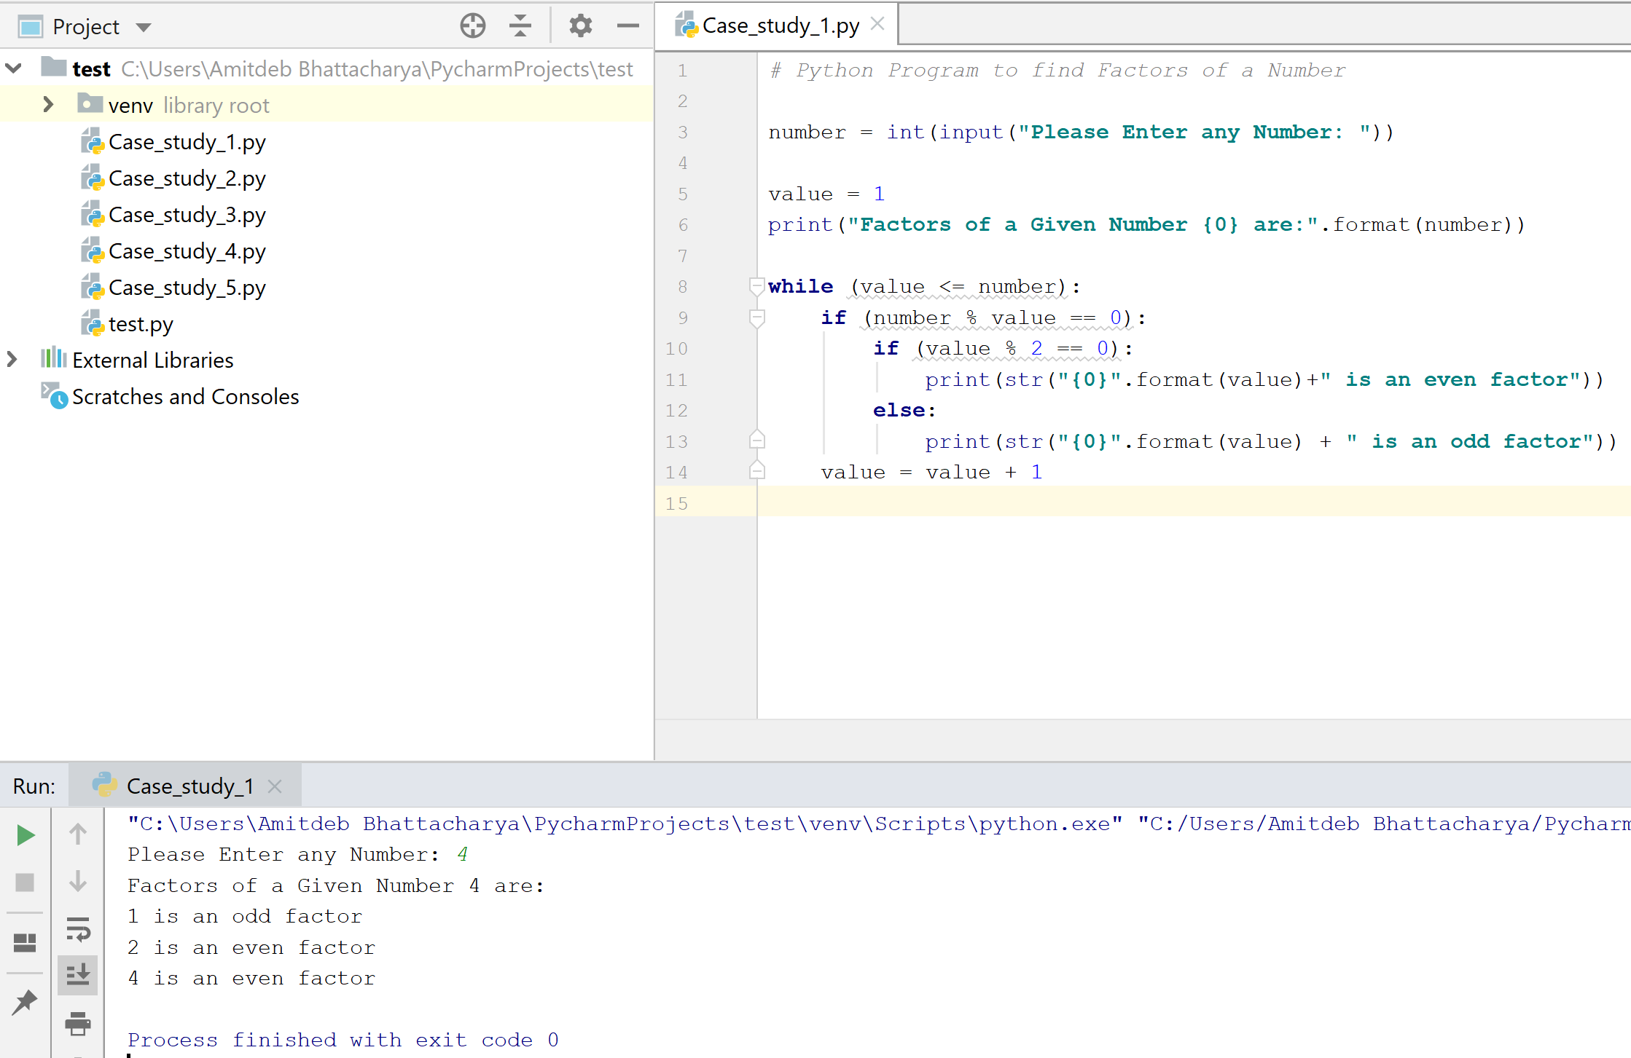



**2. Write a code which accepts a sequence of words as input and prints the words in a sequence after sorting them alphabetically.**

**Hint: In case of input data being supplied to the question, it should be assumed to be a console input.**

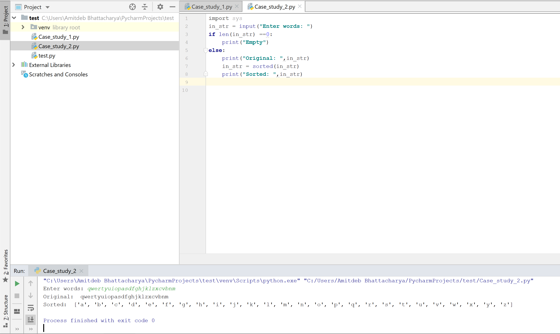



**3. Write a program, which will find all the numbers between 1000 and 3000 (both included) such that each digit of a number is an even number. The numbers obtained should be printed in a comma separated sequence on a single line.**

**Hint: In case of input data being supplied to the question, it should be assumed to be a console input. Divide each digit with 2 and verify is it even or not.**

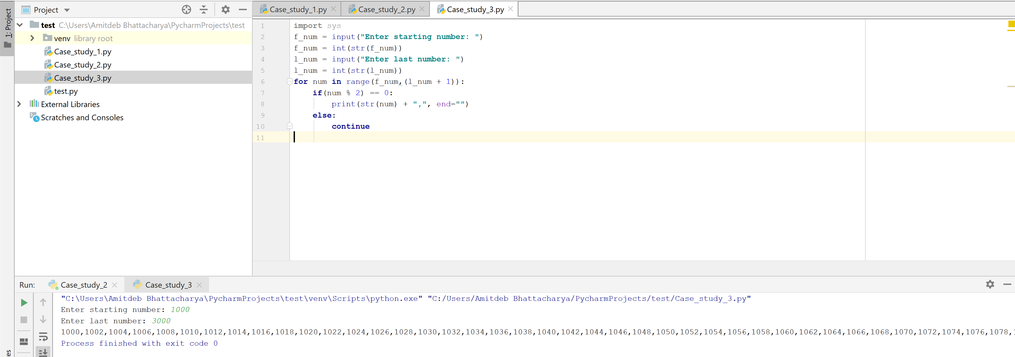



Note: After the number 3000 an extra comma is coming that I couldn’t handle.

**4. Write a program that accepts a sentence and calculate the number of letters and digits. Suppose if the entered string is: Python0325**

**Then the output will be:**

**LETTERS: 6**

**DIGITS:4**

**Hint: Use built-in functions of string.**

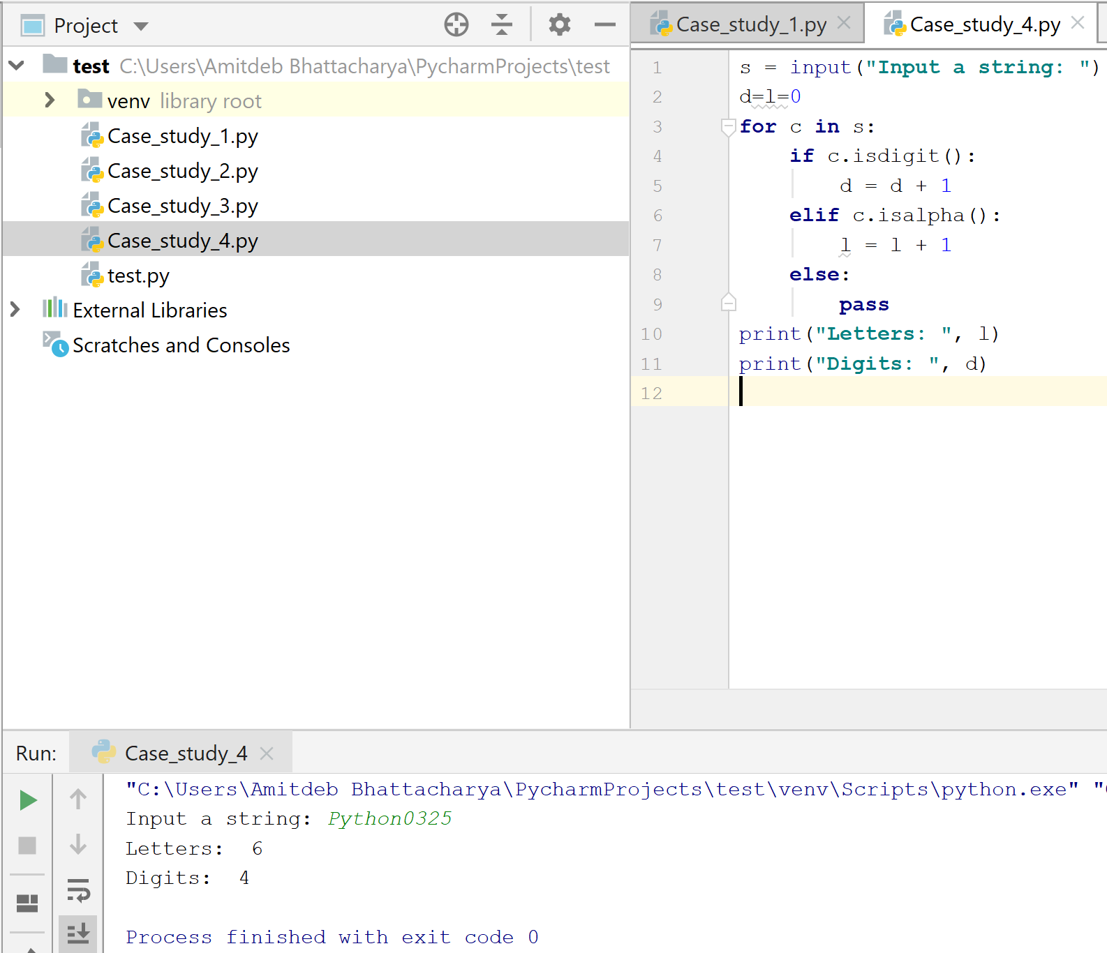



**5. Design a code which will find the given number is Palindrome number or not.**

**Hint: Use built-in functions of string.**

